2023-24 Nation Building Grant Application

The Nation Building program provides funding opportunities to First Nations and Tribal Councils in British Columbia to support nation-building activities according to their self-determined priorities. A project or initiative meant to strengthen the institutional, governance, and community capacities in reclaiming and rebuilding resiliency, self-determination, and sovereignty, within each Nation’s own context is considered an eligible project.
Applicants can apply for 1-year funding for up to a maximum of $60,000 for their project or for 2-year funding for up to a maximum of $120,000. Applicants may apply and be approved for multiple projects – so long as the overall total does not exceed $60,000 per applicant per fiscal year. For greater clarity, applicants that are approved for 2-year ($120,000) funding can only be approved for new funding once that existing project and funding has been completed.
Approved funding amounts will be determined by project complexity, demonstrated need and available funding.

Important Dates
NRT will begin to accept completed applications on May 18, 2023, until funds are exhausted OR December 1st, 2023 – whichever comes first.

Who Can Apply?
This initiative is available to:

- BC First Nations Communities / Organizations
  - BC First Nations – Single First Nations or Partnering First Nations
  - Organization/Development Corporation applying on behalf of their First Nation

- Tribal Councils
  - BC Tribal Councils administering a project on behalf of themselves or multiple First Nations.

Ineligible Organizations include:
  - Non-Profit Societies, Associations, Friendship Centres, Committees, Collectives, and other similar organizations
  - Private or Public Businesses

Eligible Projects
NRT will consider any projects meant to strengthen the institutional, governance, and community capacities in reclaiming and rebuilding resiliency, self-determination, and sovereignty within each Nation’s context.
Example project types are listed below. It is a non-exhaustive list, so if you are unsure if your project is eligible, you may contact us before applying to validate the project concept or idea.
Governance
- Policy Development (consultation, financial, administrative, education, compensation, etc.)
- Law development, by-law development, Citizenship codes, Title and Rights work
- Impact Benefit Agreements
- Negotiation Agreements
- Professional and Technical Assessments
- Corporate Governance and Economic Development Planning
- Feasibility studies
- Administrative system upgrades and implementation

Community
- Capacity building training for staff & community programs.
- Community Energy planning
- Community Strategy and Visioning (Community engagement, land use, food security, employment, housing, safety, etc.)
- Cultural & language revitalization planning (digitization and historical archiving, story telling, tourism development, child and family services, archaeological and genealogical studies, etc.)
Eligible Expenses
NRT will consider eligible expenses as costs that are tied to the execution and success of a project. NRT will evaluate each project’s budget within the context of the application, but applicants are strongly encouraged to spread NRT funds across multiple cost categories.
Examples of eligible expenses are listed below:
- Professional, legal, technical, and consulting fees (quotes are required if this cost category exceeds $15,000 or 20% of total requested funds),
- Community engagement costs,
- Supplies, materials, and equipment costs,
- Capital materials and software purchases,
- Project related capacity development, mentorship, Elder, knowledge sharing and training costs.
- Other reasonable administrative costs or any incremental costs associated with the project.

Ineligible Expenses
- Existing administration and overhead costs not relevant to an applicant’s project
- Existing staff wages, salaries, or top-ups / honorariums to current employees
- Capital expenditures not directly related to the project.

Funding Approval / Evaluation Process
NRT review committee will review applications upon submission based on organization and project eligibility, application completeness and validity of nation-building concept or idea. Please allow up to 2 weeks after submitting a fully complete application to receive a funding decision.
Deliverable and Reporting Requirements
This initiative aims to share nation-building resources, knowledge, and lessons learned on completed projects such that other Nations contemplating a same or similar project can benefit to improve expectations of a successful project. As such, we ask approved funded applicants to submit a final brief report using a Template that will be provided to you or can be downloaded anytime on the NRT website.
Application coaching/assistance and Submission information
The New Relationship Trust is available to work with potential applicants. If you have questions, require assistance, or wish to request an application discussion, please reach out to us.

Completed applications, questions, final reports and other follow-up matters can be submitted to Matt Cook-Contois and Lisa Paull at:
nationbuilding@nrtf.ca

Application Checklist (please submit all documentation for this application)
☐ Completed application form
☐ Letter of Authorization
☐ Professional/Consultant Quote(s) (if cost category exceeds $15,000 or 20% of total ask)
☐ Additional Documentation to support proposal (optional)

2023-24 NATION BUILDING APPLICATION
DEADLINE: Each application is reviewed and approved as it is submitted. We will accept applications until funds are exhausted or by December 1st 2023.
The purpose of the Nation Building Program is to provide funding opportunities to First Nations and Tribal Councils in British Columbia to support their nation building activities according to their self-determined priorities. A project or initiative meant to strengthen the institutional, governance, and community capacities in reclaiming and rebuilding resiliency, self-determination, and sovereignty, within each Nation’s own context is considered an eligible project.
Instructions: Please respond to questions below, and email a completed application along with supporting documentation to Matt Cook-Contois and Lisa Paull at: nationbuilding@nrtf.ca

SECTION A – Applicant Information
Click which one applies to you: | ☐ BC First Nation  ☐ BC First Nation Organization  ☐ BC Tribal Council
Name of First Nation/Organization or Tribal Council:
Project Contact Name: (first & last name)
Job Title:
Email Address:
Call back Phone Number:
Secondary Project Contact Name, Email & Phone: (if applicable)
Registered Mailing Address of Applicant organization:

SECTION B – Project Information
Project Title/Name:
Provide a brief project overview:
Proposed Start Date:
Proposed End Date:
Is the Request for 1-year or 2-year funding?
What is the total $ amount of funding you are requesting from NRT?
(1-year funding cap $60,000)
(2-year funding cap $120,000)

Summarize:

Identify the primary objectives and expected outcomes of the project.
* You may attach a business plan or other type document that supports the submission.

SECTION C – Project Activities and Timeline
Identify the major steps, phases, or milestones associated with this project:

*brief bullet points of the milestones or steps the Nation/Tribal Council/organization expects to be completed during the life of the project.

What deliverable(s) (tangible and other) do you propose the NRT can receive upon completion:

*In the spirit of reciprocity NRT aims to learn from each Nation-building project to enhance programs and develop capacity tools and, in some cases, to share successes, challenges, and when appropriate provide certain template deliverables amongst Nations.
Documents NRT receives as confidential will not be shared outside of the NRT.

SECTION D – Project Budget
Provide draft budget | Please refer to the eligible expenses in the preamble of the document.
List Expenses Below  Please list the major project cost categories and their associated costs to complete the project.  Also, if the proposed budget includes costs for a particular consultant /contractor/service provider, that is budgeted to receive $15,000 or more of the NRT Grant, please list that consultant or contractor or servicer provider as part of the itemized costs. | Total Proposed Budget  Amount (including funding from other sources) | $Amount  Requested from NRT
Total Expenses | $ | $

SECTION E – Supporting Documentation
* you can attach in a separate email if you prefer or if the file is too large to attach in this form.
To attach a document to this form: Place cursor in the box to the right and follow the steps on the last page of this Form.

First Nation Communities/Organizations:
Attach a letter of authority:  *We are looking for a basic authorization statement (on appropriate letterhead) from an individual that has the authority to affirm the project has been or is internally approved in your organization. This authorization can be a BCR or a statement signed by the Chief, CAO/CEO, Dept or Division head, or other individual with that authority.  ** As a sample, you can copy and paste onto your organization letterhead, the text in the column at the right. | (For Copy and Paste)  To NRT,  Project Start Date: ___________________________  Project Name: ____________________________________  NRT Funding Request Amount: __________  Project Contact Person: _________________  The project application as presented is approved to be submitted to NRT.  NAME_____________  Title ______________  Signature ____________________

For Tribal Councils Representing Multiple First Nations
Please list the First Nations that will be involved or directly benefit from this project:

Quotes – Applicants must attach quotes if total costs exceed $15,000 or 20% of request from NRT.
Attach Professional, Legal, Technical, and/or Consultant Quotes

- required only if cumulative work of one contractor/consultant/service provider is $15,000 or more

Other Documents
Attach any document(s) such as business plans, work plans, concept plans, reports etc. that can support the project application.

* Can attach to this application (see instructions on last page) or send separately by email.

SECTION G – Application Checklist
Click which applies to you. | ☐ Completed application form  ☐ Letter of Authorization  ☐ Professional/Consultant Quote(s) (if line items cost exceeds $15,000)  ☐ Additional Documentation to support proposal (optional)

INSTRUCTIONS TO ATTACH A DOCUMENT TO THIS FORM.

Attaching or embedding another word document, power point, or a PDF document within this NRT Form is a very useful putting all information in one place. With digital documents becoming more important these days, it is a handy and helpful way to manage documents.
In Microsoft Word, place your cursor where you’d like the document to be located. Then,
1. Go to the Insert tab > Object.
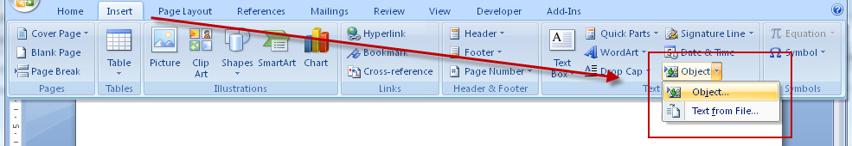
2. In the Object dialog, go to the Create from File tab
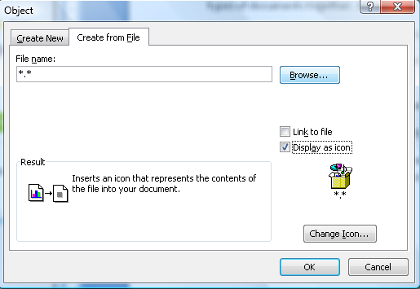
3. Click on Browse. Search and select the PDF file you wish to embed.
4. Select Display as icon and leave Link to file unchecked. You can choose to change the icon if you wish.
5. Click on OK.

