2023-24 BC First Nation Elders Application

The New Relationship Trust (NRT) recognizes the importance of the roles our Elders play in nation-building especially in terms of strengthening and sustaining healthy and vibrant indigenous communities.

Important Dates
NRT will begin to accept completed applications on May 18, 2023, until funds are exhausted OR December 1st, 2023 – whichever comes first.

Who Can Apply?
These initiatives are available to BC First Nations Elder groups and to BC First Nation organizations that support First Nation elders.

Purpose
The purpose of this initiative is to contribute to enhancing the overall wellbeing of First Nations Elders in their communities.

Eligible Expenses or Projects
We welcome a wide range of innovative concepts and ideas for small projects, gatherings, initiatives, and other projects that support elder health, wellness, recreation, experiences, learning, language, and culture preservation etc.

Examples of Ineligible Expenses or Projects
- Existing administration costs and overhead costs
- Capital expenditures not directly related to support the project or initiative.
- Existing staff wages or salaries

Maximum Funding Amount
The maximum annual amount available is $8,000 per First Nation.

Application Checklist (please submit all documentations in the application):
- Completed Application Form
- Letter of authorization from the associated BC First Nation/organization on respective letterhead
- If applicable: Other documentation, project quotes, workplans etc, that can support the application.

Approval / Evaluation Process
NRT review committee will validate applications upon submission based on organization and project eligibility, application completeness and alignment of project with spirit and intent of program purpose. Please allow up to 2 weeks after submitting a fully complete application to receive a funding decision.

Reporting Requirements
If successful in your application, we will ask you to provide a brief final report on the outcome of the project in terms of successes, challenges, and impacts. The final report can include written parts, photos, and other innovative ways to summarize the outcome of the project. A Final Report template will be provided to each funding recipient or can be downloaded anytime on the NRT website.

Application coaching/assistance and Submission information
The New Relationship Trust is available to work with potential applicants. If you have questions, require assistance, or wish to request an application coaching session to validate your project concept or idea, please reach out to us.

Completed applications, questions, final reports, and all coaching requests for funding can be submitted to:

Applications can be emailed to:

elders@nrtf.ca

2023-24 BC First Nation Elders Application
DEADLINE: We will accept applications until funds are exhausted or by December 1, 2023.
This Grant recognizes the importance of the roles our Elders play in nation-building especially in terms of strengthening and sustaining healthy and vibrant indigenous communities.
The funding is meant to be flexible to meet the unique and diverse needs of each First Nation grant recipient.
Instructions: Please respond to the application questions below, and email a completed copy along with required documents to: elders@nrtf.ca

SECTION A – Application Information
Click which applies to you. | ☐ BC First Nation  ☐ BC First Nation Organization  ☐ BC First Nation Elder Group
Name of First Nation/Organization or Elder Group:
*Primary Project Contact Name, Position, Email & Phone:
2nd Project Contact Name, Email &Phone (if applicable)
Registered Mailing Address of applicant organization:
*Primary contact must an employee of the First Nation/Organization or Elder Group

SECTION B – Project Information
Project Title/Name
Proposed Start Date
Proposed End Date
Amount of requested funds from the NRT
Provide a brief description on what the requested funds will be used for.

*You can alternatively attach a supporting document such as project work plan, proposal, or brochure etc.
List expected positive outcomes & benefits of the proposed use of funds.

*If possible, think of the short-term benefits but also the potential longer term positive outcomes for the Youth and the broader community.

SECTION C - Budget
Provide draft budget.
Amount Requested to the NRT | $
Please list the major project cost categories and their associated costs.  Also, if the proposed budget includes costs for a particular consultant/contractor/service provider, please list that consultant, contractor, or service provider as part to the itemized budget below. | Total Proposed Budget  Amount (including funding from other sources) | $Amount  Requested from NRT Only
Total Budgeted Expenses | $ | $

SECTION D – Supporting Documentation
* You can attach this in a separate email if you prefer or if the file is too large to attach in this form. To attach a document to this form: Place cursor in the box to the right and follow the steps on the last page of this Form.

First Nation Communities/Organizations:
Attach a letter of authority:  *We are looking for a basic authorization statement (on appropriate letterhead) from an individual that has the authority to confirm the project has been or is internally approved in your organization. This authorization can be a brief statement signed by the Chief, CAO/CEO, Dept or Division head, or other individual with that authority.  ** As a sample, you can copy and paste onto your organization letterhead, the text in the column at the right. | (For Copy and Paste)  To NRT,  Project Start Date: ___________________________  Project Name: ____________________________________  NRT Funding Request Amount: __________  Project Contact Person: _________________  The project application as presented is approved to be submitted to NRT.  NAME_____________  Title ______________  Signature ____________________

SECTION E – Application Checklist
Click which applies to you. | ☐ Completed application form;  ☐ First Nation /Organization letter of authorization on letterhead.

I understand that the information submitted in and with this application will be used to assess your eligibility for a NRT Grant. I hereby certify that all the information provided in this application form and in all the documents accompanying it is true, accurate and complete. By submitting this application, I agree to be bound by the policies and guidelines of this Grant initiative.

Signature of Applicant: |  | Date:

Print Name:

INSTRUCTIONS TO ATTACH A DOCUMENT TO THIS FORM.
Attaching or embedding another word document, power point, or a PDF document within this NRT Form is a very useful putting all information in one place. With digital documents becoming more important these days, it is a handy and helpful way to manage documents.
In Microsoft Word, place your cursor where you’d like the document to be located. Then,
1. Go to the Insert tab > Object.
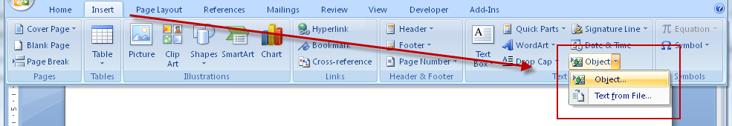
2. In the Object dialog, go to the Create from File tab
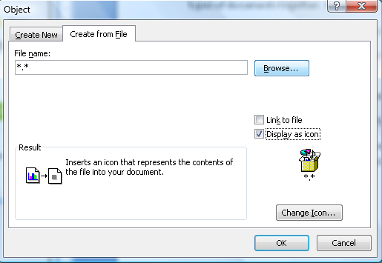
3. Click on Browse. Search and select the PDF file you wish to embed.
4. Select Display as icon and leave Link to file unchecked. You can choose to change the icon if you wish.
5. Click on OK.

